24.60: a) With the switch open:
. By symmetry, each
capacitor carries 4.20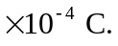 The voltages are then just calculated via V=Q/C.
So:
b) When the switch is closed, the points c and d must be at the same potential, so the equivalent capacitance is:
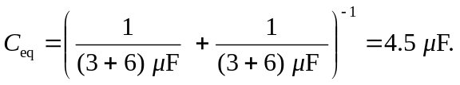
and each capacitor has the same potential difference of 105 V (again, by symmetry)
c) The only way for the sum of the positive charge on one plate of and the negative charge on one plate of to change is for charge to flow through the switch. That is, the quantity of charge that flows through the switch is equal to the charge in 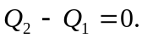 With the switch open, 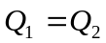 and After the switch is closed, 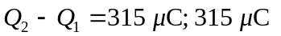of charge flowed through the switch.

